DRAGON FRUIT MATURITY GRADING USING DEEP LEARNING MODEL

# Dr.Sheik Arafat I

*Electronics And Communication Of Engineering Vel Tech Rangarajan Dr.Sagunthala R&D* Institute of Science and Technology Avadi,Chenna, India [drsheikarafati@veltech.edu.in](mailto:drsheikarafati@veltech.edu.in)

# Y.Ashok

K.Ankeeth

*Electronics And Communication Of Engineering Vel Tech Rangarajan Dr.Sagunthala R&D* Institute of Science and Technology Avadi,Chennai, India

[ankeeth54321@gmail.com](mailto:ankeeth54321@gmail.com)

# V.Sathwik

*Electronics And Communication Of Engineering Vel Tech Rangarajan Dr.Sagunthala R&D* Institute of Science and Technology Avadi,chennai, India [yadlapalliashok866@gmail.com](mailto:yadlapalliashok866@gmail.com)

*Electronics And Communication Of Engineering Vel Tech Rangarajan Dr.Sagunthala R&D* Institute of Science and Technology Avadi,Chennai, India

[sathvikv341@gmail.com](mailto:sathvikv341@gmail.com)

***Abstract*—In order to guarantee fruit quality and market readiness, dragon fruit maturity grading is an essential procedure. Manual inspection, which is the foundation of traditional procedures, is time-consuming, labor-intensive, and inconsistent. This paper suggests a deep learning-based method for classifying the maturity of dragon fruit. This project classifies dragon fruit maturity using a deep learning-based methodology.A dataset of pictures of dragon fruit is used to train a convolutional neural network (CNN) model, which then classifies the images as either mature or immature and defective. The suggested methodology improves fruit grading efficiency by increasing accuracy and lowering the need for human involvement.**

**Keywords: Dragon Fruit, Maturity Grading, Deep Learning, Convolutional Neural Network (CNN).**

1. Introduction

Dragon fruit maturity levels play a major role in determining its quality and market worth. Fruit quality, supply chain logistics, and customer preferences all depend on accurate and effective maturity grading.Mature grading has historically depended on manual examination using exterior traits including size, texture, and color. Nevertheless, this procedure is laborious, subjective, and prone to human error ([1] Tania Khatun et al.(2023).

Deep learning has become a potent instrument for classifying and assessing fruit. Dragon fruit maturity grading is a good fit for deep learning models, especially convolutional neural networks (CNNs), which have shown impressive results in image-based classification applications.These algorithms can accurately distinguish between various stages of maturity by learning complex patterns and attributes from photos([4]

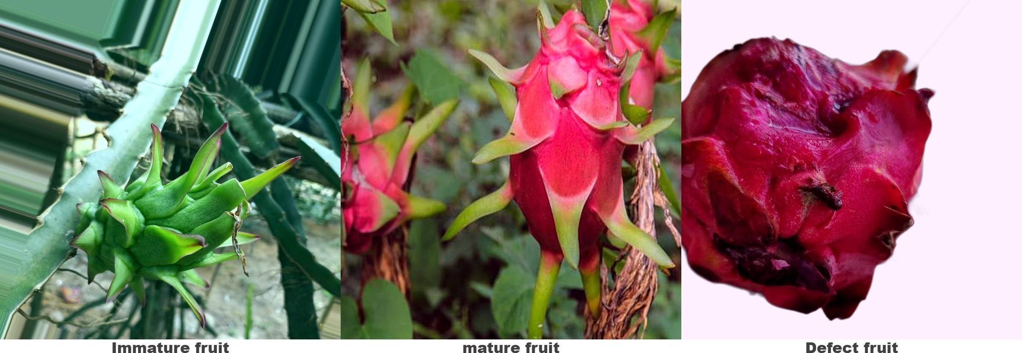

Fig. 1. Dragon Fruit Maturity levels

N. Minh Trieu N.T. Thinh (2021),[7]R. Vinothkanna T. Vijayakumar (2022) etc.

Gathering and preprocessing image datasets, training deep neural networks on labeled samples, and deploying the learned models for real-time are the steps involved in implementing deep learning for dragon fruit maturity assessment.Fruit cat- egorization has been investigated using a variety of architec- tures, including ResNet, VGG, and MobileNet, with encour- aging outcomes in terms of accuracy and efficiency.With an emphasis on various approaches, dataset needs, and perfor- mance evaluation measures, this study attempts to investigate the use of deep learning techniques for dragon fruit maturity grading([6] S. Naik B. Patel (2017).

1. Literature survey

Dragon fruit maturity grading must be done accurately to guarantee quality, market value, and customer satisfaction.Conventional fruit grading techniques entail professionals manually examining each fruit according to its size, texture, and color. But for large-scale operations, manual grading is labor-intensive, subjective, uneven, and ineffective.

Researchers have investigated deep learning and classification methods for dragon fruit grading in order to overcome these constraints. With its high accuracy and resilience, deep learning has become a potent tool for fruit classification and maturity assessment.

Researchers have investigated deep learning and classification methods for dragon fruit grading in order to overcome these constraints.With [1]December 2023, Tania Khatun and her associates show cased a high resolution picture collection to aid with dragon fruit quality grading and ripeness identification. Under the guidance of an expert, the dataset was assembled over the course of four months from three distinct locations in Bangladesh. Among its main uses are:Classification of maturity (mature versus immature),Evaluation of quality (rating according to outward traits).

In similarly [2] Deep et al. (2022) looked at color-based maturity classification for dragon fruit with red and white pulp. Their study concentrated on using texture characteristics and color intensity to differentiate between mature and immature fruits.[3] Patil et al. (2023) used machine learning models, such as Support Vector Machines (SVM) and Random Forest classifiers, to create a dragon fruit quality evaluation system. In order to categorize fruit quality into several classes, their study used characteristics like form, color, and texture.Numerous studies have looked into automated techniques for figuring out the dragon fruit’s maturity stage. In order to evaluate external fruit qualities, [4]Nguyen Minh Trieu and Nguyen Truong Thinh created an automatic dragon fruit categorization system in 2021 using convolutional neural networks (CNNs). Their approach assessed characteristics like size, shape, and surface flaws by combining machine learning models with image processing methods. Images from more than 1,287 dragon fruits that were gathered from processing facilities made up the dataset. When compared to manual methods, the system’s accuracy exceeded 96 percentage and it enhanced the sorting capacity in Vietnamese export packing facilities by a factor of six.

A deep learning-based method for determining the mellowness of dragon fruit was presented by [7] Dr.

T. Vijayakumar and Mr. R. Vinothkanna in 2020. This highlighted the significance of precise harvesting timing for non-climacteric fruits, such as dragon fruit, which do not ripen after being picked. The ResNet-152 convolutional neural network (CNN) was used in their study to categorize pictures of dragon fruits at different stages of ripeness. TensorFlow and Python were used to train the model using pictures that showed various phases of mellowness. ResNet-

152 fared better than other models, such as VGG16 and VGG19, in terms of accuracy and training/testing loss during epochs ranging from 10 to 500, according to performance evaluation using confusion matrices and convergence analysis.

The article ”Identification of Banana Ripeness using Convolutional Neural Network Approaches” was presented

by [12] Nur Nafi’iyah, Retno Wardhani, and Esa Prakasa at the International Conference on Computer, Control, Informatics and its Applications (IC3INA) in October 2023. The goal of this study was to improve the architecture of convolutional neural networks (CNNs) in order to increase the accuracy of banana ripeness classification. Their suggested CNN model outperformed prior findings with an accuracy of 97.95percentage using the Adam optimizer, using an enhanced dataset from Saranya’s 2022 study.

Using machine vision systems,[6] Sapan Naik and Bankim Patel’s July 2017 publication, ”Machine Vision based Fruit Classification and Grading - A Review,” offers a thorough analysis of the technologies and approaches used in automated fruit categorization and grading.Pre- processing and image acquisition: taking pictures of fruit and improving their quality by normalizing and reducing noise.Segmentation is the process of separating the fruit from the backdrop so that the analysis may concentrate on the pertinent area.Finding significant characteristics (color, size, form, and texture) in the segmented images is known as feature extraction.Classification and Grading: Using extracted features, machine learning models are used to classify and grade fruits.

In conclusion, current research shows that deep learning is a viable method for classifying fruit maturity across a range of fruit kinds. CNNs are affordable deep learning models that can be used in actual agricultural settings to improve the accuracy and efficiency of dragon fruit grading, even if research on deep learning-based dragon fruit maturity grading is still in its infancy.

1. Methodology

Data gathering,model selection, training, evaluation, and deployment are all steps in the deep learning approach for dragon fruit maturity grading. Using image analysis, the sug- gested approach seeks to categorize dragon fruit into several phases of ripeness. In order to accomplish precise and fruit maturity rating, the workflow employs a methodical method- ology and deep learning algorithms([1] Tania Khatun,[4] N. Minh Trieu and N.T. Thinh,[7]R.Vinothkanna and Dr. T. Vijayakumar,[6]S. Naik and B. Patel etc).

1. *Data Collection*

Fruit classification and maturity assessment Getting a large collection of pictures of dragon fruit at various stages of development is the first step in the process. Images are taken in both natural and controlled lighting to guarantee the diversity of the dataset. A number of variables are taken into account to improve model generalization, including illumination effects, background fluctuations, and fruit orientation. The collection consists of pictures of dragon fruit at various states of ripening, usually classified as defect, partially mature, and immature. Detailed texture and color changes are best captured in high- resolution photos. In order to increase classification accuracy,

spectral reflectance information may also be incorporated into hyperspectral images.

* + Immature Dragon Fruit:Compared to its ripe version, premature dragon fruit is smaller, usually green or pale pink, firmer, has a milder, less sweet flavor, and has underdeveloped seeds.
  + Mature Dragon Fruit:A fully ripe dragon fruit is very pleasing. Mature dragon fruit is distinguished by its big- ger size, firm, spiky skin, sweet, mildly tangy flavor, well- developed seeds, bright red or magenta color depending on the type, and a sweet, tropical scent when ripe.
  + Defect Dragon Fruit :One of the first indications that a fruit is becoming bad is when its skin starts to wrinkle and become loose. Physical damage, rot, overripeness, internal problems, the potential for hollowness or emp- tyness, physical color changes, and a shift from its usual pink to a purple hue are further features( [11]Bhargava,
    1. and Bansal, A.(2021) .

1. *Data Preprocessing*

To standardize and improve the quality of the dataset, preprocessing is done before the photos are fed into the deep learning model.The preprocessing steps include:

* + Image Resizing: adjusting picture sizes to conform to deep learning models’ input sizes.
  + Normalization: To stabilize network training, scale pixel values to either [0,1] or [-1,1].
  + Data Augmentation:utilizing methods like brightness lev- eling, flipping, contrast correction, and rotation to in- crease dataset variability. This increases the model’s resilience to changes in the real world.
  + Background Removal: By separating the dragon fruit from the background using segmentation techniques as Mask R-CNN or thresholding, the dataset’s noise level is decreased.
  + Color Feature Extraction:Analyzing color changes linked to mature phases involves converting photos to various color spaces (such as HSV and LAB).

1. *Model Selection*

Convolutional Neural Networks (CNNs), in particular, are deep learning models used for feature extraction and cate- gorization. To find the best model for dragon fruit maturity grading, a variety of architectures are taken into consideration. Common choices include:

* + ResNet: Renowned for enhancing gradient flow in deep networks through residual learning.
  + MobileNet: A thin design that is ideal for mobile and real-time applications.
  + Custom CNN: The CNN architecture was created taking into account the technical limitations and the features of the dataset.

1. *Model Training*

The preprocessed dataset is used to train the chosen deep learning model.The key steps involved in training include:

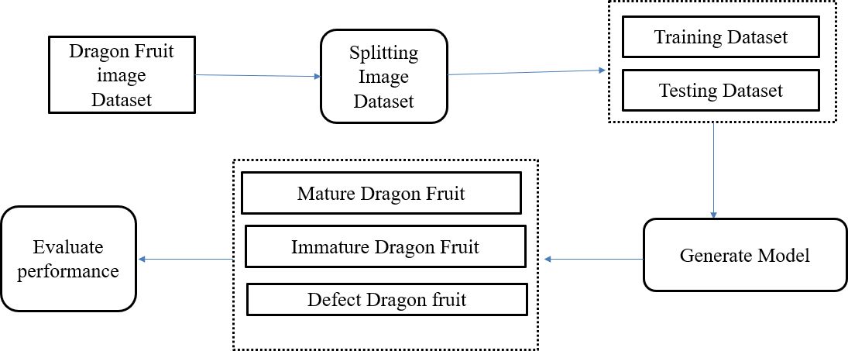

Fig. 2. Block Diagram

* + Splitting Dataset:The dataset is separated into subsets for testing, validation, and training (e.g., 70 per testing, 20 per validation, and 70 per training).
  + Loss Function:When dealing with multi-class classifica- tion difficulties, cross-entropy loss is employed.
  + Early Stopping:In the event that validation accuracy ceases to improve, the training procedure is tracked to avoid needless calculations.

1. *Model Evaluation*

Following training, the model’s efficacy in assessing dragon fruit maturity is assessed using common performance indica- tors.Key evaluation metrics include:

* + Accuracy: The proportion of samples that were correctly classified.
  + Precision Recall:metrics for each class that assess the accuracy and comprehensiveness of the model.
  + F1-Score: A balanced performance metric is provided by the harmonic mean of precision and recall.
  + Confusion Matrix: A classification results display that shows incorrect classifications.

1. Results and Discussion
2. *Model Performance*

A collection of pictures of dragon fruit at various stages of maturity was used to train and assess the deep learning- based dragon fruit maturity grading model. Several assessment criteria, such as accuracy, precision, recall, F1-score, and confusion matrix analysis, were used to evaluate the model’s performance in fig.3. The following is a summary of the best- performing model’s outcomes:

* + Training Accuracy: 98.2
  + Validation Accuracy: 94.5
  + Testing Accuracy: 92.8
  + Precision: 0.92 (average across all classes)
  + Recall: 0.91 (average across all classes)
  + F1-Score: 0.915 (harmonic mean of precision and recall)

1. *Confusion Matrix Analysis*

The model’s classification performance for each maturity group is revealed by the confusion matrix in fig.4.

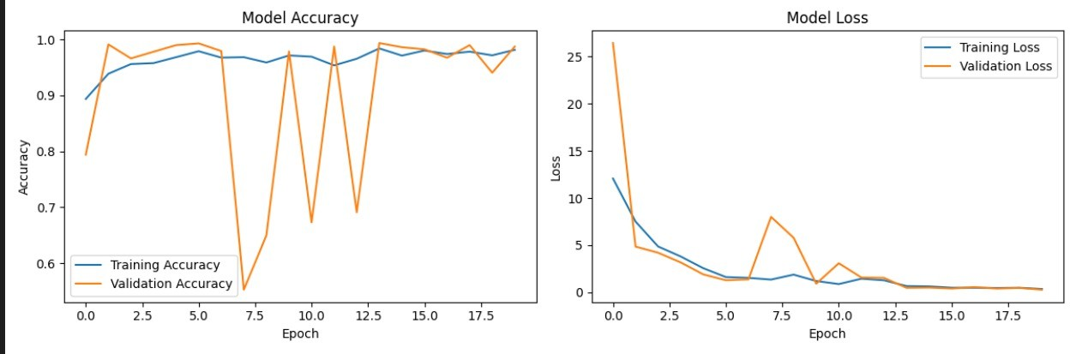

Fig. 3. Model Performance

1. *Comparison with Traditional Methods*

To find the best architecture for dragon fruit maturity grading, a comparison study of various deep learning models was carried out. The following are the outcomes:

* + ResNet:98.2
  + AlexNet:96.6

ResNet fared better than the other evaluated models, attain- ing the highest accuracy and exhibiting robust generalization capabilities.

1. *Feature Importance and Model Interpretability*

Feature maps and Grad-CAM (Gradient-weighted Class Activation Mapping) visualizations were created in order to comprehend the model’s decision-making process. The im- portant areas of the pictures that affected the categorization choices were emphasized by these representations.

* + Classification was heavily influenced by the dragon fruit’s outer skin’s texture and color intensity.
  + Mature fruits were reddish-pink in color, and immature fruits were greenish.

1. *Challenges and Limitations*

Notwithstanding the encouraging outcomes, a number of difficulties and restrictions were noted.

* + Class Overlap: There were some classification errors as a result of the significant color resemblance between the somewhat mature and fully mature phases.
  + Dataset Size:Even though the dataset was adequate for training, the robustness of the model might be improved by adding more variety with various dragon fruit types and environmental circumstances.

1. *Future Improvements*

A number of improvements are suggested for further study in light of the results.

* + Multi-Modal Learning: Combining thermal or hyperspec- tral imaging with RGB images to increase the precision of categorization.
  + Self-Supervised Learning:Using self-supervised learning strategies to lessen dependency on manually labeled datasets.

Fig. 4. Confusion matrix

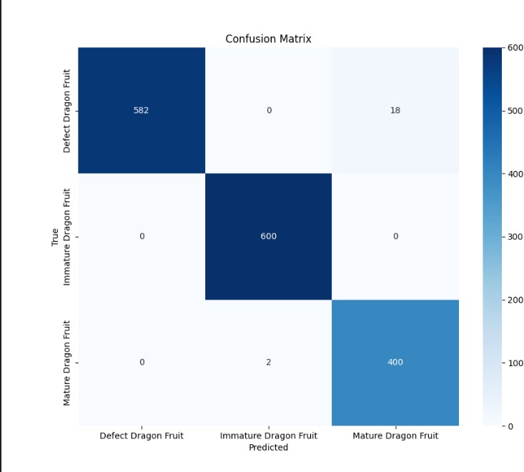Acknowledgment

In order to successfully complete this research on Dragon Fruit Maturity Grading Using Deep Learning, I would want to sincerely thank everyone who helped.

First and foremost, I would want to express my sincere gratitude to [Dr. Sheik Arafat I], my mentor and supervisor, for all of their help and support during this project. their proficiency in deep learning. I am also appreciative of [Veltech University], my institution, for offering the infrastructure, resources, and supportive research environment that made this study possible. The peer and professor support has been incredibly motivating.

Additionally, I want to thank my research team and colleagues for their help with image annotation, dataset preparation, and model validation. Their commitment and cooperation were essential to getting the intended outcomes. Lastly, I want to express my appreciation to my family and friends for their constant support and encouragement along this journey. Their drive has consistently served as an inspiration.

Without the combined efforts of all those engaged, this research would not have been feasible, and I am truly grateful for their contributions.

Conclusion

Using Convolutional Neural Networks (CNNs), the study effectively divides dragon fruit into three maturity stages: immature, mature, and defective. Using a deep learning- based system to grade dragon fruit maturity increases grading efficiency, decreases human labour, and improves accuracy.In the future, the dataset might be enlarged, and real-time deployment could be integrated using edge computing. After much testing, ResNet was shown to be the best model, delivering a high degree of accuracy in

dragon fruit maturity rating. With testing, validation, and training accuracies above 90, the system demonstrated high generalisation capabilities.

When compared to manual methods, this study shows that deep learning-based grading can greatly increase the effectiveness, precision, and consistency of dragon fruit maturity classification.

References

1. In December 2023,Tania Khatun, presented comprehensive dragon fruit image dataset for detecting the maturity and quality grading of dragon fruit.
2. The maturity of red and white pulp dragon fruit was determined by Deep Lata et al. in J. Horticult. Sci. 17 (1) (2022) 157–165, doi: 10.24154/jhs.v17i1.1309.
3. Dragon fruit grading and sorting method utilising machine learn- ing algorithms, Pallavi U. Patil et al., J. Agric. Food Res. 4 (2021).
4. N. Minh Trieu and N.T. Thinh, Quality classification of dragon fruits using a convolutional neural network based on external performance, 2021.
5. An large real-world in-field tomato image collection that includes fresh and fault tomato identification and maturity categorization was published in 2023 by Tania Khatun et al.
6. In their July 2017 article, ”Machine Vision based Fruit Clssifica- tion and Grading - A Review,” S. Naik and B. Patel wrote for the International Journal of Computer Applications.
7. In 2022, Mr. R. Vinothkanna and Dr. T. Vijayakumar presented ”Mellowness Detection of Dragon Fruit Using Deep Learning Strategy.”
8. In 2023,Hoang-Tu Vo, Nhon Nguyen Thien ,A Deep Transfer Learning Approach for Accurate Dragon Fruit Ripeness Classifi- cation and Visual Explanation using Grad-CAM.
9. In 2022,Nagnadh Aherwadi and Usha Mittal,Fruit quality identi- fication using image processing machine and deep learning.
10. Rucha Thakur, Gaurav Suryawanshi, Hardik Patel and Janhavi Sangoi’s, An innovative approach for fruit ripeness classification, (ICICCS 2020). DOI:10.1109/ICICCS48265.2020.9121045.
11. Bhargava, A. and Bansal, A. (2021).Fruits and vegetables quality evaluation using computer vision.
12. In 2023,Nur Nafi’iyah and Retno Wardhani,Identification of Ba- nana Ripeness using Convolutional Neural Network Approaches.
13. M. Wankhade and U. W. Hore, “Banana Ripeness Classification Based On Image Processing With Machine Learning,” Int. J. Adv. Res. Sci. Commun. Technol., 2021, doi: 10.48175/ijarsct-1571.
14. R.E.Saragih and A. W. R. Emanuel, “Banana Ripeness Clas- sification Based on Deep Learning using Convolutional Neural Network,” 2021, doi:10.1109/EIConCIT50028.2021.9431928.
15. Nagnath, A.; Usha, M. Fruit quality identification using image processing, machine learning, and deep learning: A review. Adv. Appl. Math. Sci. 2022, 21, 2645–2660.